**Yahoo Finance: An Overview**

**(Presented By Alan Stuart K)**

**1. Introduction:**

Yahoo Finance is a comprehensive financial platform that serves as a one-stop resource for investors, traders, and financial professionals. Originally launched by Yahoo in 1997, it has evolved into a prominent online hub providing a wide range of financial information, tools, and services. Here’s a breakdown of its key **features and functionalities**:

* **Market Data**: Yahoo Finance offers real-time and historical data on stocks, bonds, commodities, currencies, indices, and cryptocurrencies. Users can track market movements, view stock quotes, and monitor performance metrics.
* **News and Analysis**: It provides up-to-date financial news, analysis, and insights from reputable sources like Reuters, Bloomberg, and Yahoo’s own editorial team. This helps users stay informed about market trends, company developments, and economic events.
* **Portfolio Management**: Users can create and manage personalized portfolios, track investments, monitor performance, and analyse diversification strategies. Portfolio tools include charts, performance metrics, and customizable watchlists.
* **Educational Resources**: Yahoo Finance offers educational content through articles, videos, tutorials, and webinars. Topics cover investment strategies, financial planning, market analysis techniques, and beginner to advanced trading concepts.
* **Community and Social Features**: It incorporates social elements such as discussion forums, comment sections, and user-generated content. This allows users to share insights, discuss market trends, and engage with a community of investors and traders.
* **Mobile Accessibility**: Yahoo Finance is accessible via its website and mobile apps (iOS and Android), enabling users to access financial data and tools on the go.
* **Global Reach**: Yahoo Finance provides coverage of global financial markets, making it a valuable resource for international investors seeking insights into diverse economies and asset classes.
* **Customization**: Users can personalize their experience by creating custom watchlists, setting alerts for price movements or news updates, and accessing real-time data streams for premium subscribers.
* **Integration**: It integrates seamlessly with Yahoo’s ecosystem, allowing users to access news articles, editorials, and insights from reputable financial sources directly alongside market data.
* **Comparison Tools**: Users can compare stocks, ETFs (Exchange-Traded Funds), mutual funds, and indices using interactive charts and performance metrics, facilitating informed investment decisions.
* **Mobile Accessibility**: The Yahoo Finance mobile app enables users to stay connected and access financial data and tools conveniently from their smartphones or tablets, ensuring flexibility and real-time updates on the go.

**2. Terminologies Involved:**

Yahoo Finance uses various financial terms and metrics essential for understanding and analysing investments. Here are some key terminologies:

* **Stock Quotes**: Real-time or delayed prices of publicly traded companies listed on stock exchanges.
* **Market Indices**: Benchmarks like the S&P 500, Dow Jones Industrial Average, NASDAQ Composite, etc., representing overall market performance.
* **Dividends**: Payments made by companies to shareholders from their earnings.
* **Market Cap**: Total market value of a company’s outstanding shares, calculated by multiplying the share price by the number of shares outstanding.
* **Volume**: Number of shares traded in a stock or an entire market within a specified time period.
* **PE Ratio (Price-to-Earnings Ratio)**: Ratio of a company’s current share price to its earnings per share, indicating its valuation relative to earnings.
* **EPS (Earnings Per Share)**: Portion of a company’s profit allocated to each outstanding share of common stock.
* **Beta**: Measure of a stock's volatility in relation to the market.
* **Yield**: Income generated from an investment, usually expressed as a percentage of its price.
* **Moving Average**: Average price of a security over a specified time period, used to identify trends and support/resistance levels.
* **Technical Indicators**: Beyond basic terms, Yahoo Finance offers advanced technical indicators such as MACD (Moving Average Convergence Divergence), Bollinger Bands, and Fibonacci retracements for technical analysis enthusiasts.
* **Market Commentary**: Users can access expert analysis and market commentary from industry professionals, providing nuanced perspectives on market trends, economic indicators, and geopolitical developments.
* **Screeners**: Yahoo Finance provides customizable screeners to filter stocks based on specific criteria such as market cap, sector, dividend yield, and performance metrics like P/E ratio or EPS growth.
* **Economic Calendar**: It features an economic calendar highlighting key economic events, earnings releases, and Federal Reserve meetings that can impact market movements and investor sentiment.
* **Valuation Metrics**: Yahoo Finance includes comprehensive valuation metrics such as Price-to-Sales (P/S) ratio, Price-to-Book (P/B) ratio, and EBITDA (Earnings Before Interest, Taxes, Depreciation, and Amortization), aiding in comparative analysis and investment valuation.

**3. Concepts Involved:**

Yahoo Finance covers a broad spectrum of financial concepts crucial for investors and traders:

* **Investing**: Allocating money with the expectation of generating income or profit over time.
* **Trading**: Buying and selling financial assets (stocks, bonds, commodities, etc.) to capitalize on short-term price movements.
* **Portfolio Management**: Constructing and maintaining a diversified portfolio aligned with investment goals and risk tolerance.
* **Technical Analysis**: Using historical price and volume data to forecast future price movements based on patterns, trends, and indicators.
* **Fundamental Analysis**: Evaluating a company’s financial health and performance using its financial statements, ratios, and market position.
* **Risk Management**: Strategies to minimize potential financial losses while maximizing returns.
* **Market Trends**: Identifying and analysing patterns in market behaviour, such as bull and bear markets, sector rotations, and economic cycles.
* **Personal Finance**: Managing individual finances, budgeting, saving, investing, retirement planning, and tax strategies.
* **Global Markets**: Understanding and monitoring international markets, exchange rates, geopolitical events, and their impact on investments.
* **Sector Analysis**: Users can analyse sector-specific performance, identifying top-performing industries and assessing sector rotation trends impacting investment strategies.
* **Sentiment Analysis**: Beyond technical and fundamental analysis, Yahoo Finance integrates sentiment analysis tools that gauge investor sentiment based on social media trends, news sentiment, and options market activity.
* **Risk Management Strategies**: It provides insights into risk management strategies such as stop-loss orders, hedging techniques, and portfolio diversification strategies to mitigate potential losses and optimize risk-adjusted returns.
* **Algorithmic Trading**: For sophisticated users, Yahoo Finance offers insights into algorithmic trading strategies, quantitative analysis, and back testing tools to automate trading decisions based on predefined criteria.
* **Corporate Actions**: It tracks corporate actions such as mergers and acquisitions, stock splits, dividends, and earnings announcements, enabling users to stay informed about company-specific developments affecting stock prices.

### 4. Advantages & Disadvantages:

#### **Advantages:**

* **Comprehensive Data**: Extensive coverage of global financial markets, assets, and economic indicators.
* **User-Friendly Interface**: Easy navigation, intuitive tools, and customizable features for users of all experience levels.
* **Real-Time Updates**: Provides timely and accurate information, including news updates and market data.
* **Educational Resources**: Offers a wealth of educational content to help users improve financial literacy and make informed decisions.
* **Community Engagement**: Facilitates interaction among users, fostering discussions, sharing insights, and building a community around financial topics.
* **Market Insights**: Yahoo Finance provides detailed insights into market trends, economic indicators, and geopolitical events through expert analysis and comprehensive data coverage.
* **Educational Content**: It offers educational resources ranging from beginner tutorials to advanced trading strategies, empowering users to enhance their financial literacy and make informed investment decisions.
* **Community Engagement**: Users can engage with a vibrant community of investors and traders, sharing insights, strategies, and market perspectives through forums and comment sections.
* **Accessibility**: With a user-friendly interface and mobile app accessibility, Yahoo Finance ensures convenient access to financial data, news updates, and analytical tools across various devices.

#### **Disadvantages:**

* **Delayed Data**: Free services may have delayed stock quotes and market updates compared to premium services or dedicated financial terminals.
* **Limited Advanced Tools**: Advanced traders may find the technical analysis tools and data customization options limited compared to specialized financial platforms.
* **Advertising**: Presence of advertisements on the website and apps, which can sometimes be intrusive or distracting.
* **Reliance on Third-Party Sources**: While Yahoo Finance aggregates data from reputable sources, discrepancies or delays in data updates may occur due to external factors.
* **Competitive Alternatives**: Users seeking advanced analytics, proprietary research, or specialized financial tools may consider alternative platforms offering more tailored services.
* **Data Delays**: Free services may have delayed data updates compared to premium financial terminals or direct exchange feeds, potentially impacting the timeliness of investment decisions.
* **Limited Customization**: Advanced users seeking highly customizable charting tools, proprietary research, or complex trading algorithms may find Yahoo Finance’s offerings relatively basic.
* **Advertising**: The presence of advertisements within the platform can sometimes detract from user experience, although they help maintain the service's free availability.
* **Reliability on Third-Party Sources**: Yahoo Finance aggregates data from multiple sources, which can lead to discrepancies or delays in data updates depending on external factors beyond its control.
* **Competitive Alternatives**: Users requiring specialized financial analytics, institutional-grade data feeds, or sophisticated trading platforms may explore alternatives offering more tailored solutions.

**5. Graphs: Comprehensive Analysis and Visualization of Apple Inc. (AAPL) Stock Performance Using Yahoo Finance Data (2023):**

**Graph 1:** Stock Price Trend:

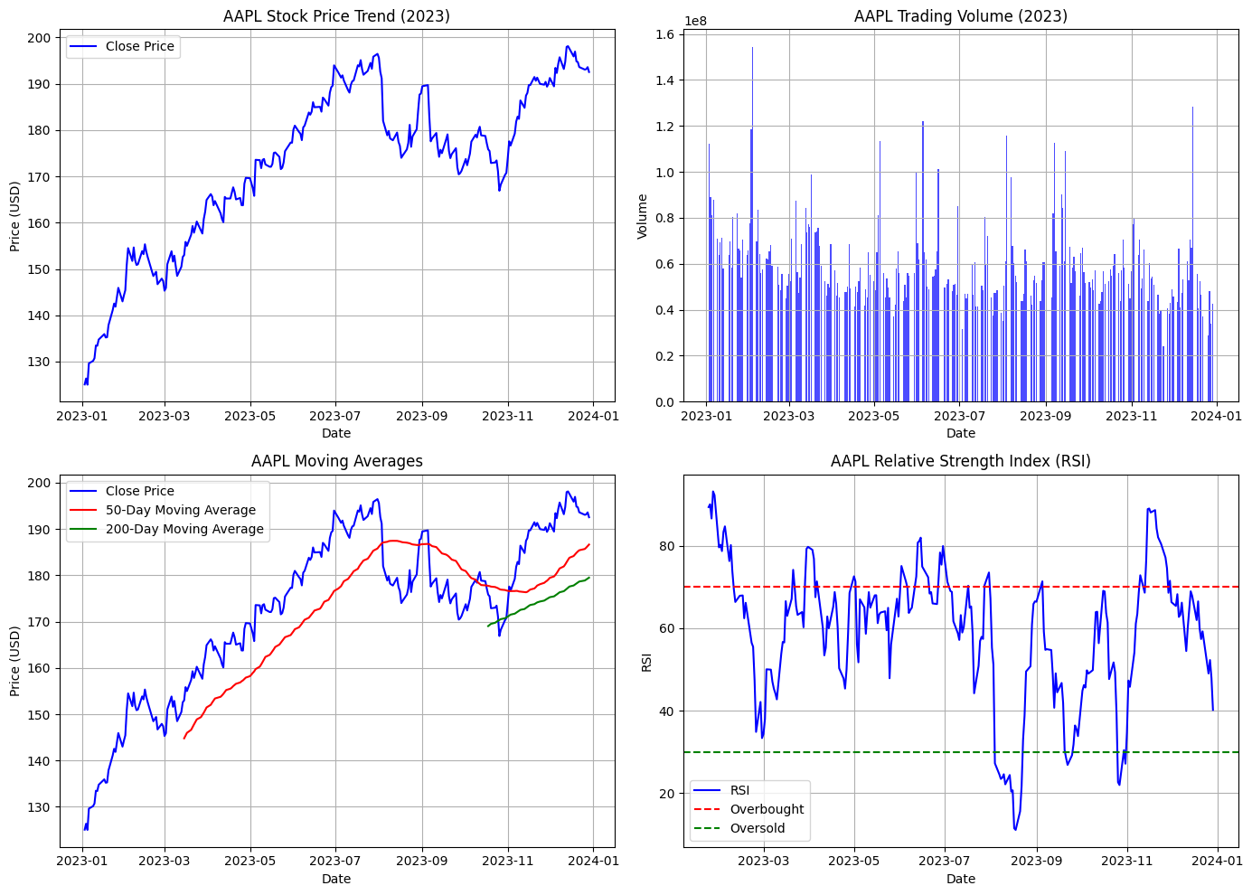**Inference:**

* **Stock Price Trend**: Throughout 2023, Apple's stock price experienced notable fluctuations, reflecting varying investor sentiment and market conditions. Key observations include:
  + **Upward Trends**: Periods where the stock price consistently rises, often driven by positive earnings reports, product launches, or broader market optimism.
  + **Downward Trends**: Instances of price declines, possibly influenced by market corrections, macroeconomic factors, or company-specific news.

**Graph 2:** Volume Analysis:

**Inference:**

**Volume Analysis**: Trading volume shows significant spikes at certain points, indicating heightened market activity:

* **High Volume with Price Increase**: Typically suggests strong buying interest and potential bullish momentum.
* **High Volume with Price Decrease**: May indicate selling pressure and potential bearish sentiment among investors.

**Graph 3:** Moving Averages:



**Inference:**

* **50-Day and 200-Day Moving Averages**: Moving averages help smooth out price fluctuations and identify trends:
  + **Golden Cross (Bullish Signal)**: When the 50-day moving average crosses above the 200-day moving average, it suggests a potential uptrend or bullish momentum.
  + **Death Cross (Bearish Signal)**: Conversely, when the 50-day moving average crosses below the 200-day moving average, it indicates a potential downtrend or bearish momentum.
* **Observation**: In the graph, observe instances where the stock price intersects or moves away from these moving averages. These crossovers can serve as signals for traders and investors to adjust their positions based on trend reversals or continuations.

**Graph 4:** Relative Strength Index (RSI):

**Inference:**

* **RSI Interpretation**: The RSI oscillates between 0 to 100 and helps assess whether a stock is overbought or oversold:
  + **Overbought (Above 70)**: Indicates that the stock price may have risen too far, too fast, and could potentially experience a price correction or reversal.
  + **Oversold (Below 30)**: Suggests that the stock price may have fallen too sharply and could potentially rebound.
* **Application**: Use RSI levels alongside price movements and volume to confirm potential entry or exit points:
  + **Confirmation Signals**: For example, if the stock price is reaching new highs with RSI above 70 and high volume, it may signal a potential pullback or consolidation.

**Graph 5:** Close Price with Moving Averages: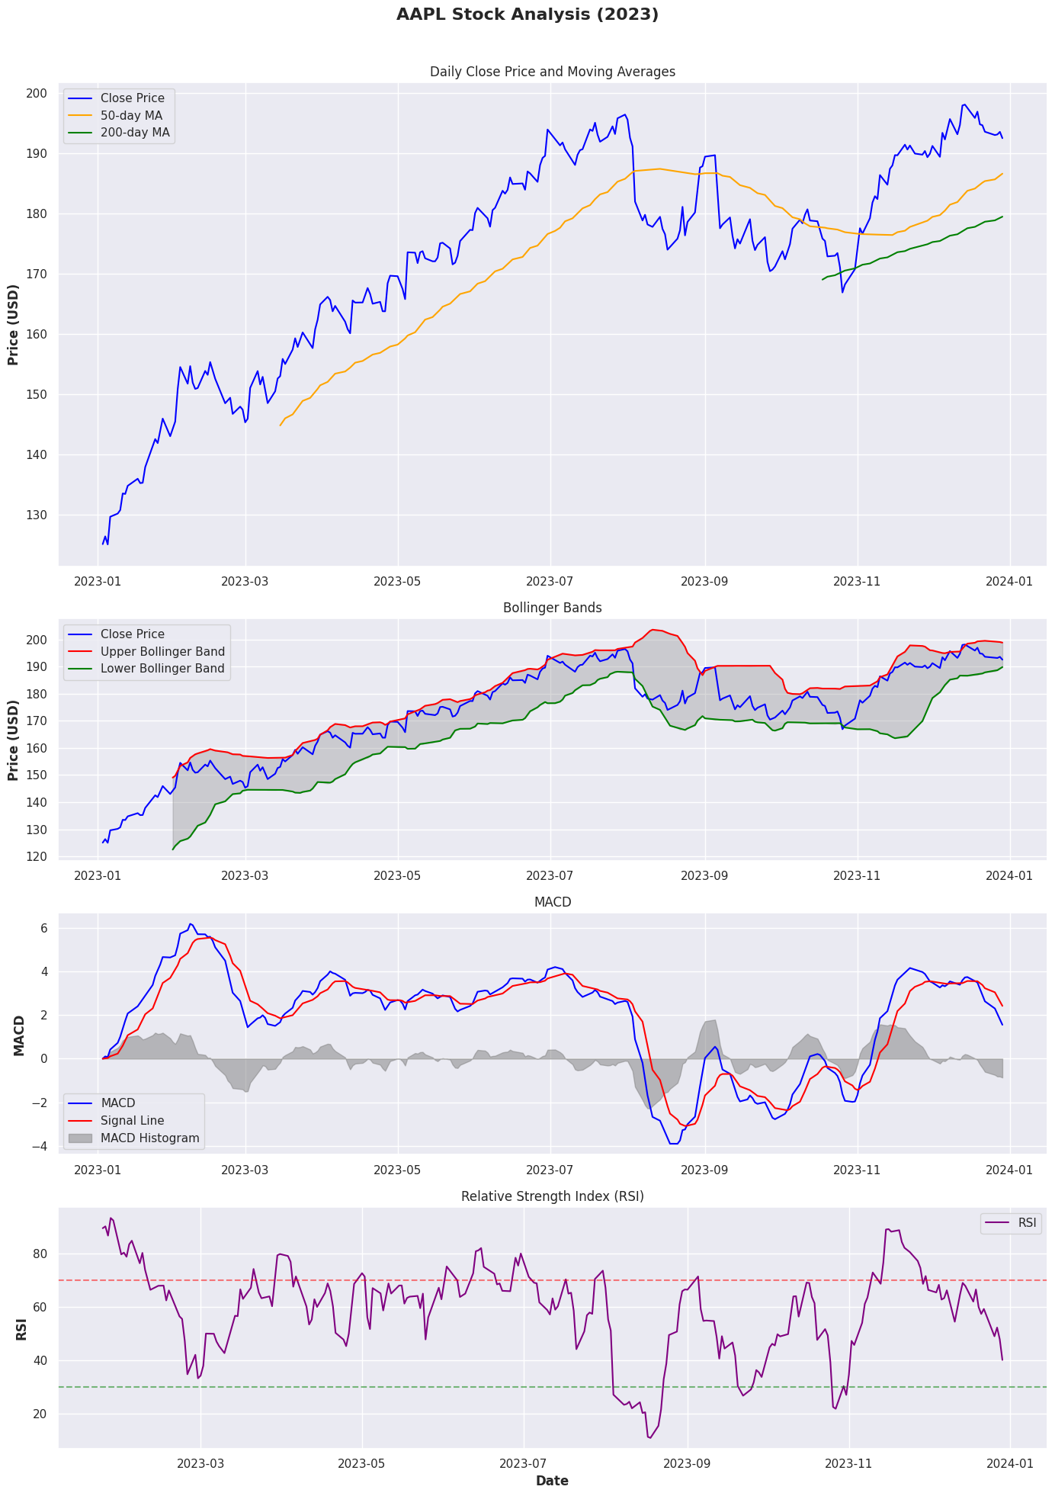**Inference**:

* **Trend Identification**: The graph shows the daily closing price of AAPL along with the 50-day and 200-day moving averages, which helps in identifying the overall trend.
* **Golden Cross**: When the 50-day MA crosses above the 200-day MA, it indicates a potential long-term uptrend.
* **Death Cross**: When the 50-day MA crosses below the 200-day MA, it suggests a potential long-term downtrend.

**Graph 6:** Bollinger Bands:

**Inference**:

* **Volatility Measure**: Bollinger Bands expand and contract based on price volatility.
* **Overbought/Oversold Conditions**: Prices near the upper band may be overbought, while prices near the lower band may be oversold.
* **Mean Reversion**: Prices tend to revert to the mean (20-day SMA), making Bollinger Bands useful for identifying potential reversal points.

**Graph 7:** MACD (Moving Average Convergence Divergence):



**Inference**:

* **Trend Strength and Direction**: The MACD line and the signal line help in identifying the strength and direction of the trend.
* **Buy/Sell Signals**: A crossover of the MACD line above the signal line indicates a buy signal, while a crossover below indicates a sell signal.
* **Histogram**: The histogram represents the difference between the MACD and the signal line, providing a visual representation of momentum changes.

**Graph 8:** Relative Strength Index (RSI):

**Inference**:

* **Overbought/Oversold Conditions**: RSI values above 70 suggest that the stock is overbought, while values below 30 suggest it is oversold.
* **Trend Strength**: RSI helps in identifying the strength of the trend, with strong trends often remaining in overbought or oversold territory for extended periods.
* **Divergence**: Divergence between RSI and price can indicate potential reversals. A bullish divergence occurs when the price makes a new low but RSI makes a higher low, while a bearish divergence occurs when the price makes a new high but RSI makes a lower high.

**Conclusion:**

Yahoo Finance is a comprehensive platform providing extensive financial data, real-time quotes, and a variety of tools for technical and fundamental analysis, making it invaluable for investors and financial analysts. Through the analysis of Apple Inc. (AAPL) stock using moving averages, Bollinger Bands, MACD, and RSI, we demonstrated how these indicators help identify trends, measure volatility, and predict price reversals, aiding in informed investment decisions. Despite its benefits, such as user-friendly accessibility and up-to-date financial news, Yahoo Finance has some drawbacks, including ad interruptions and data delays in its free version. Nonetheless, it remains a powerful resource for developing effective trading strategies and understanding market dynamics.